Building Enterprise Financial Software in 2026: Change is comping.
I the past there were 2 options. Roll your own as per allot of the American banks, and in particular the core system. Otherwise buy something off-the-self (weather it is hosted, self-hosts) that to some degree can be tailor to the requirements of the institution. Pricing tends to be opaque, and time lines missed proportional to complexity. In both instances it takes a large teams and years of effort. Generally, these products are problematics for a multitude to reason, but the effort of replacement outweighs the benefits of replacement. Just life with it.
Nothing, has really changed here in the 30 decades I have been in software development. Sure, there have been numerous waves of news process and tooling, but few have made a real impact. From my perspective the real big wins can be put down to hardware.
Now, with better hardware, AI is finally possible. The statistical theory has been around before I was born, and I did AI theory based on work start from the 60s during my undergrad years back in the late 80s. So now we have loads of fast hardware all that theory is becoming reality. It been an epiphany for me. Most people seem to fear change and the speed it his happening only make great tabloid news. My journey has been more positive.
Nearly all my work experience has been around trading system (front, middle, and back office) as vendor solutions, enhancements to existing process, and in house-built solution. It has always been a pet project of mind to understand the business, and one day build as true technically great product that customers are deperate to have.
So given we have AI now (both for tooling and knowledge) would it be feasible to build large post trade enterprise application using an Analyst/Developer? The job title from the 1970s who did everything (product owner, BA, architect, developer, tester, and support).


Business Requirements
- Real-time post solution around positions
- Captured, sorting, enrichment, and validation of trades
- Transactions (security, cash), Postings and Positions
- Events for the lifecycles in post trade
- Entitlements (manual and automatic from external systems)
- Cash charges (taxes and fees)
- Security (Access Rights and Data)
- Flexible Reporting
- Matching and Settlements (manual and automatic to/from external system)
- AI to assist users (i.e. identify breaks and causes, hedging, etc…)
- Workflow (i.e. four eyes approval, exception management, etc…)
Technical Requirements
- Clean (understandable, maintainable, predicable) and Dry (one source of truth) Code
- Low Code (heavy use of popular libraries and annotations)
- Iterative and Dynamic Development
- Domain and Test Drive Development
- Well defined bounds (AI, Modules, Schemas, etc…)
- Observability (metrics, Logging)
- Portability (Environment party, Reproducibility, Ubiquitous)
- User of Canonical/Normalised Keys (single source of truth)
- Augment Data and not overriding the data
- Distributed Architecture (1-n instances for resilience and scaling)

Getting the most from AI
Best results will be achieved when you understand the following concepts
- AI models are probabilistic
- Underlying large corpus of high quality work will return best results
- Remove variability and ambiguity. Having clear excepted outcomes
It is these reason why AI has worked well in code generation, so the same principle need to be applied to the problem domain. Within Finance the quality of knowledge is excellent and well known (publish papers, vendor documentation, regulatory, etc…), and if we choose the technical tooling used my enterprise (and particular Finance) we should be off to a good start
So taking a statically term we should always try and choose the best quality, the bigest bell curves of give technical and functionality domain. So choosing Java, Spring, Unix, English, and Standard Financial Terminology (the “Boring Tech Stack”).
It should also be pointed out the input context are limited, so if you need to explain your DSL, or Architecture design you will have less space to explain what you want to do. That applies to “skills” and “rules” files. For example I chose Hexagonal Design Pattern (Post and Adapters) for the application as it is a well known, well defined package naming convention. DO in my input context I only have to state a we words to ensure the LLM knows, it does not have to infur, which will lead to worse results. So clean design patterns a repeated though thoughout the code base. Less moving parts, onlt the business functionality is changing.
Since LLM reply of probability and the origins of probability come from gambling we want to have a “The Stacked Deck” of playing cards to ensure the best outcome. As a useless side fact Bayes theorem was developed by Thoms Bayesian who a theologian (no a gamebler) trying to prove mathematical the existence of gods actions.
An remember, models will hallucinate rather than say I do not know [Nature: 22/Apr/2026: Evaluating large language models for accuracy incentivizes hallucinations]

Workbench UI
This is one area that AI excels. UI frameworks and demos galore, but I choose boring. The less code the better. Very corporate looking, Operations workbench / BFF. Functionality over form. Minimize visual “shine” and maximize simplicity + user productivity. So let it be a hyper media front end with plain java script were it is really needed. No websockes for now, but request/response and some REST. Other UI can be tailored for given requirements (mobile apps for clients), would be sperate projects using the best tool for that purpose (I has a GraphQL, gRPC, and REST endpoints, and gateway service).
No a great fan of one UI for everyone. It’s a compromise for all. For this UI it si Spring Templates generate hypermedia(unpoly/htmx) from the server. Simple (less moving parts), and perfect for fast iterative development.

REST and GraphQL
We still have REST and GraphQL web end points to communicate between the micro services along with a secured JWT tokens. GraphQL has the schema that AI seems to like and we want AI to be on grad rails (login and security)

“AI on Guard Rails”
A heavily regulated industry guard rails need to be put in place. This can done use a workflow engine and access rights. Like every real users the AI agents need to be granted access to functionality and data. Data is filter on account identifiers, access tights, and the catch all tenant

Monolith or Mico Services
Marco Services around data domains. So a bit of both. Mirco services provides very clean domain boundaries of ownership, but will also add to structural complexity. Most modules will need to know about accounts. Naturally we can perform GraphQL calls to return data that is low volume, bit for high volume functionality we will needed to cache (Reporting on trades, with account name and account code, etc…)
So the rule of thumb is you can cache other modules data you need but there is only one single source of truth.
Boundaries are not just APIs. Individual DB schema are defined for each service. This was done to expeditated development. The SQL Query builder are allied to cross schemas on the assumption other models data would be to be persisted at a latter stage. So SQL views are create as a first step, that could be transformed to materialized views or another SQL data cache functionality (based off published events from the source of this data). Why? Because you cannot beat SQL engine for generating data set results.

Architecture Design
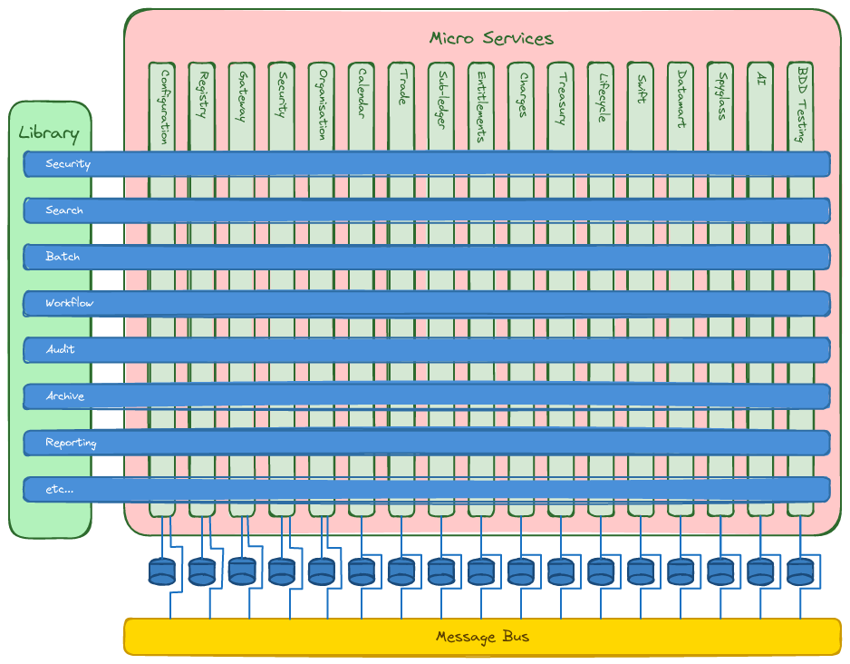

Code Base
Since a very interative development process was applied, and very strict code reviews, the code is in a view good place. Entire re-writes were common. Generally not due to bad code, but functional shake downs, and the odd epiphany. A set of design pattern were always implements in the same way, naming conventions. Keep in reshuffling and stacking the deck. AI code generate has it’s wobbles (even with API docs setup), but only a review we asked the AI the same questions
- Is any common code, patterns or functionality that already exists in the existing. Can we or should we generalize this code, functionality?
- Is business naming conventions and values being applied correctly. Are there conflicts I should be aware off.
- List out the deviations in style and design t/compare to the other model projects.
- What are the missing functionality (business and technical) this module that as yet not been implement
- Is the BDD coverage complete for the given use cases, workflow, and business processes.
- Etc…

So what does Codex think about the app that it help build:
“Illuminatio looks like a **mid-to-large enterprise financial services platform**.
It is technically a **Java/Spring Boot microservices estate** with gateway, config, registry, admin, security, messaging, GraphQL, Liquibase, observability, and many domain services.
Size-wise, it is substantial: roughly **25 services**, **2,500 main Java files**, **650 test files**, and many database migrations and BDD specs.
Design-wise, it follows **DDD / hexagonal architecture / event-driven design**, aimed at complex finance workflows like trade, settlement, treasury, subledger, SWIFT, lifecycle, and search.
In plain terms: **this is the shape of a serious banking or capital-markets backend platform**, not a small app.”
This application has taken one application develop about 12 man months of effort to build (actual is less since I worked solidly for 5 months (12 x 7). Codex

Common sub-project contains 30% of the code based. This was an iterative development with refactoring stages. The “Rule of 3” was applied no only within a sub-project, but across the entire project. This has positive, is AI found it easier to build out ned project as there we very strong patterns, the negative is how much is common. I tried to avoid business domain objects (accounts, trades, etc…) since we leave to the sub-project to choice ant store data in what ever structure suits it. However, IDs were centralise. External IDs are types, and canonical in structure. Using a strongly types language is a big plus in AI development.

Fred-Books 1986 “No Silver Bullet”
I managed to build the application to deployment stage (docker containers) in around 9 man months using AI. Compressed into 6 months (definitely out did Alibaba 996 schedule), but I want a complete product that was ready to be AI enabling “stage” since we need the tooling “stack the deck” and provide the guard rails.
So has AI made build Enterprise product fast. Definitely, this project without AI would have take a team of 7-10 people probably 2 years. It definetly compresses the time, and more source would probably make it a little fast (mythical man month).
Choose the “boring” frameowrks, libraries, etc.. helps, but I found even with Spring I was still building “infastructure”. Best to slow down at these points and ask for Options rather than fire and forget. And certain when it was all known knows and a plan was defined, you tend to get good result, and it was a review process asking a list of questions to tease out inconsistency. It also still true to iterate, a series for complete tasks, one after another with milestone reviews to correct. This works well with BDD, and even iterating with a story.

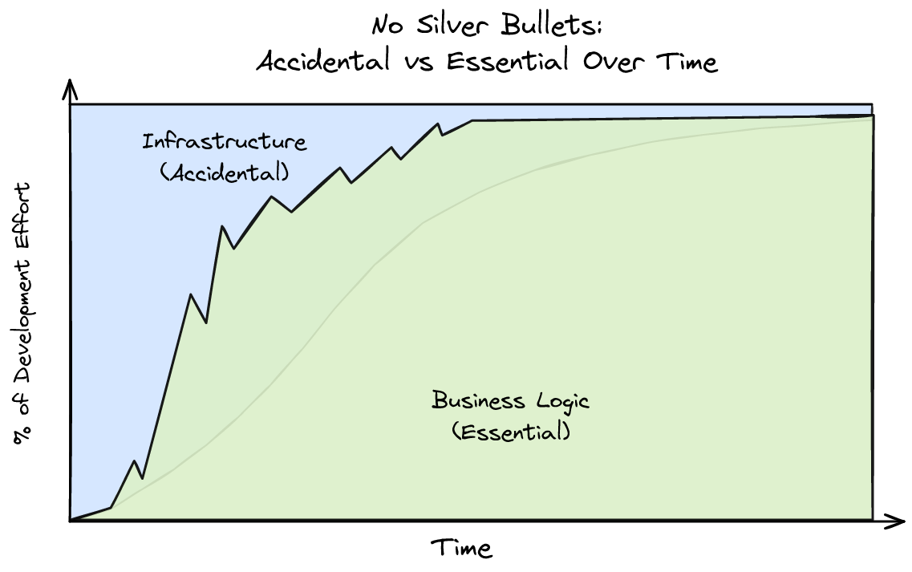

Letting Go
How do you get the most out of AI without generate “slop”?
Start with the creative stuff at the start. Build the framework (a blue print) that will 10x the AI later. This meant micro managing the development at the start, and once patterns emerge letting go, and review the results at the end. Applying the “Rule of three”. When functionality appears more than 3 times then refactor [Martin Fowler; Kent Beck; John Brant; William Opdyke; Don Roberts (1999), Refactoring: Improving the Design of Existing Code]. I switch from Augment Code inside the editor, to later just using Codex outside any editor over al the sub-modules. I still used a code editor during reviews and for debugging.

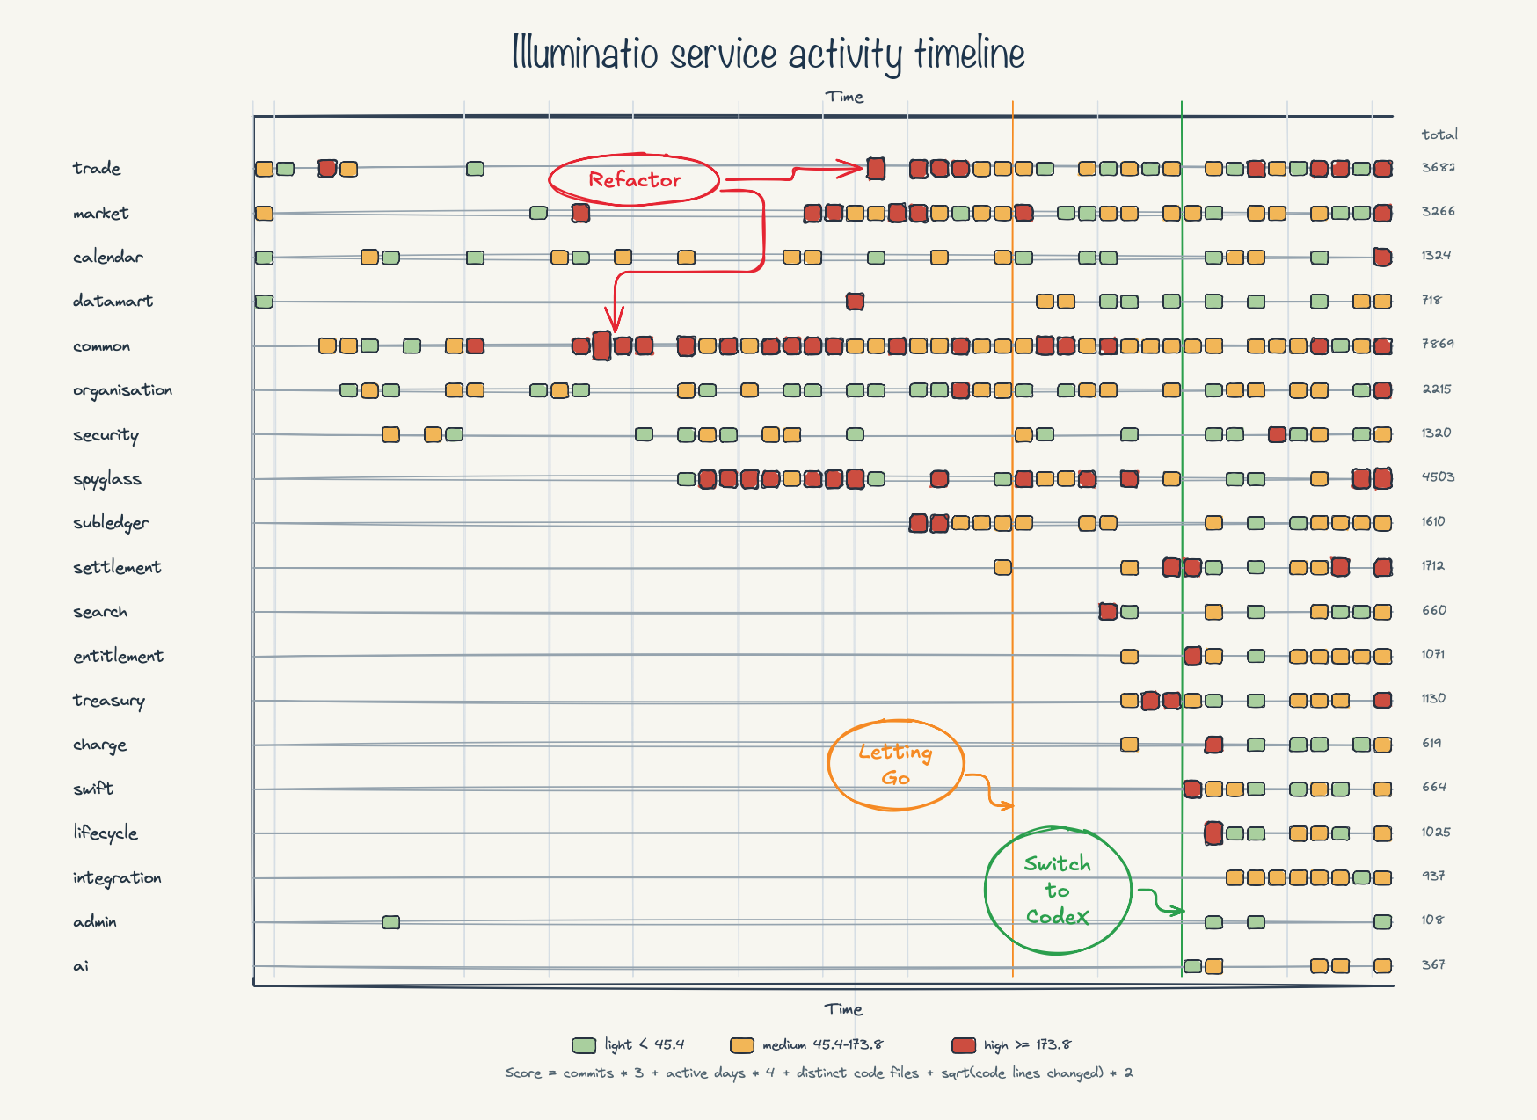
Somethings you already new were common and were pushed into common libraries from the start, and then further refined. Others small and large fell out during development. Transaction and Events was an interesting one since it unified trades, cash, and entitlements, and trade lifecycle (the diary).
We tend to build a mental mode based on our experiences, much like AI. However, we as humans can connect these dots, and sometime were there appears no connection. Something AI still struggles with this. During Analysis and design I tended to you the LLM as a second opinion. I would as for options (at least 3), but I would also play the devils advocate. Especial when try to connect dots. Is there commonality, bit technical or within domains. A financial trade is basically as series of temporal event types (that may or may not happen), that generate 0 or more transactions (how those transaction materialize will be effect by the terms of the trade). With this you can model simple trade to structure trades (that caused the 2008 meltdown), yet if you ask an LLM it will never give then opinion on a first pass.
The same technically. Exceptions and approvals are manual tasks in workflow. Developers will create sperate process and functionality, and AI will just follow the corpus of work it has learnt one. In reality they are just specify types of workflow cas, along with loads of other manual and automated flows. So n become 1 patten. Less code, less exceptions for AI. The question is can a very simple workflow engine every be created without become a beast.
In conclussion, with solid components based on well describe patterns, AI become more productive and start to implement the same pattern on in code, and hallucinated less. As for a slow down, It had quite the opposite, allot oh hand holiding an micro management at the start ,but with strong design and a common structure it sped up. A module that books weeks became days, and the using BDD to drive it was the surprise.

Stay on the Path

Behaviour Drive Development (BDD)
Given
“LLMs perform best when the problem domain constrains the space of valid outputs.”
Most of the testing is BDD testing, using a consist clean syntax of Given, When, Then steps. The model is then runup in test modes (controlling time) with test end-points, and the feature scripts a run.
This works well, the problem domain ins constrained, and the expected outputs are defined. AI will write the scripts based on the corpus of financial know.
This dirive implementation from expected behaviour, it becomes the source of truth and a living artifacts (Spec Driven Development). BDD testing is applied in both at a module level, and application level (integration). Steps at module level at used at integration. I was shocked how testing as a developer became pleasurable. Development can be done at a module level during coding, everything is being work, and AI has complete control, real rapid, iterative development. It makes testing integral to all who worked on the project.
Extensive BDD impovesettls confifidnce without make the brittle tests that occurs with UNIT test. If you can run all the BDD tests succesfully, how do confident are you that all is good.
Two points that need to be understood. You need to create a well defined set of test data that that is extends. It is constrained and iscolated for certain uses cases, they make overlap, but should be inopetent whatever the order they are run. The takes effort/planning, but is 10x the development when done well
The integration testing used docker test containers, but it should be flagged with BDD tests scripts, however in module BDD testing was outside these test containers. Just too slow to fast integration, here we fired up the module as an application but with test end-points.
Conculsions
- It only probability, so stack the Deck in your favour. Stay within the bell curve
- Iterate Fast, and use Behaviour Driven Development to drive the building on the functionality. Is you tooling up to it? 1, 3, 5, 10, or 30 minute build times and no meaningful calls stack are not conducive to productivity AI development.
- A Dry, clean code. Useable library based on well known patterns, that and use standards with a large Corpus of knowledge. Not just code, but technical and functional knowledge.
- SAAS companies are facing head winds. They will need to down size to complete will all those upstarts. We are see the layoffs to appease the investors. They will leverage with a high entry bar to sell into those instructions, but is always a friction between buy v build, and what to stop the institutions just consuming the startup and bring it in house.
- “A jack of all trades is a master of none, but oftentimes better than a master of one.” is very apt in an AI world. Does it mean the job adverts will start say Analyst/Developer.

